# CSP554—Big Data Technologies

# Assignment #3 (Modules 03a & 03b, 15 points)

Que 6)

**Ans:** a_to_n=46

other=49

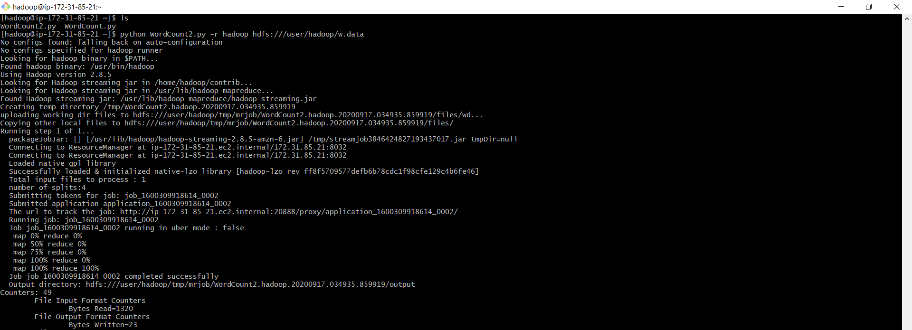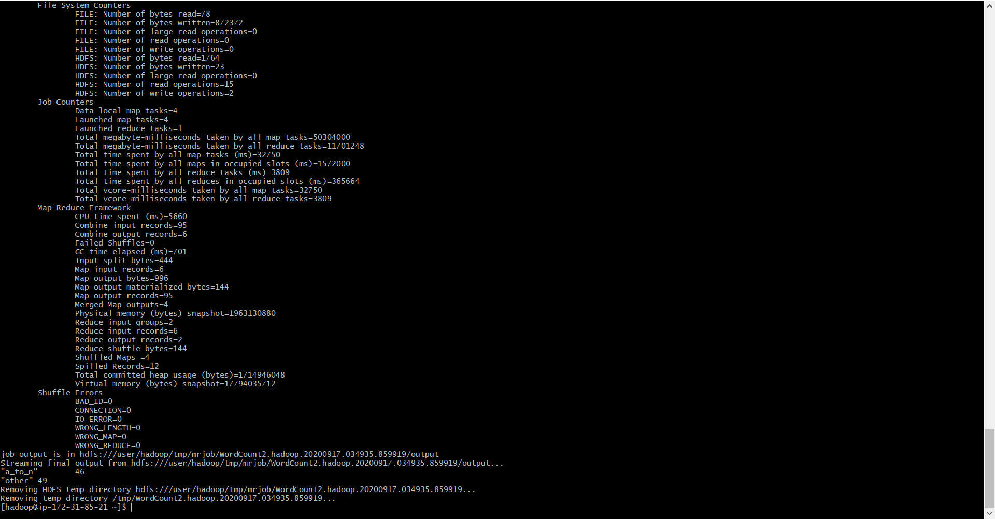

Que 10)

**Ans:**

Low=7064

Medium=6312

High=442

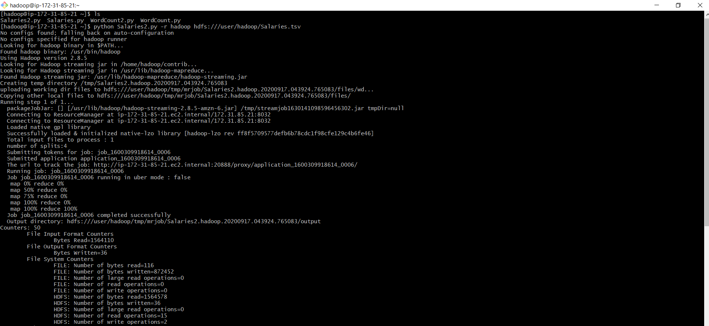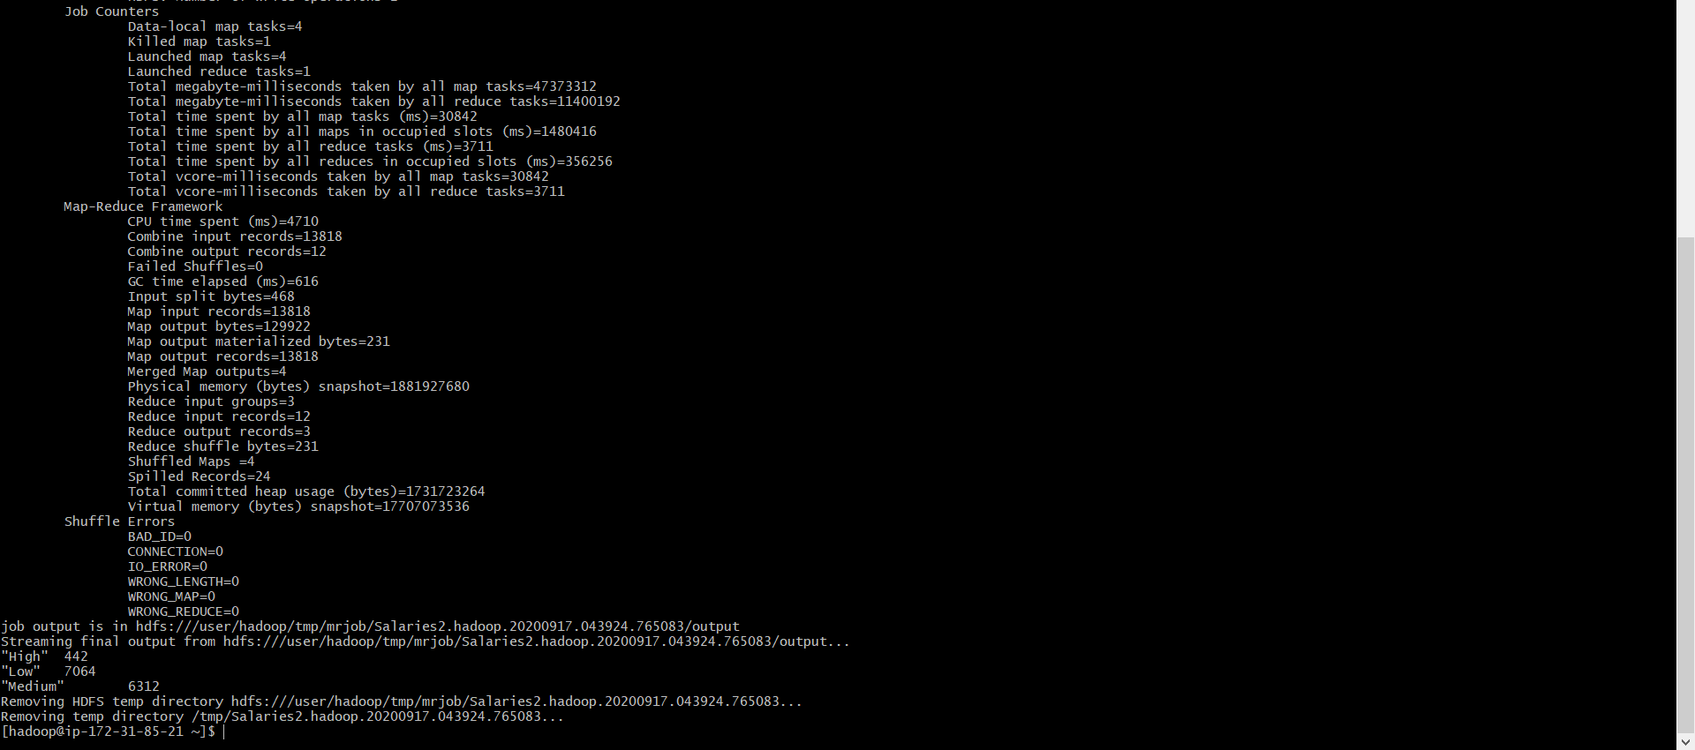

Que 12)

Ans:

